**Biometric Research Group**

**Multi-Biometric Authentication""**

**About**

Biometric systems are automated methods for authentication and identification of living individuals based on certain physical characteristics such as fingerprinting, the pattern of iris, and some of other features like hand-writing, and the switching.

Biometric methods are not the impeccable methods, in some cases they meet faults. What Biometrics Research Group of University of Science and Technology is trying to achieve, reduce errors and increase the reliability of biometric authentication systems.

The project which currently is under study is the fusion of different biometrics (at first priority fingerprinting ,Iris and, face image ) in order to achieve what was mentioned above.

Biometric laboratory of Iran University of Science and Technology establish on October 2013 under the supervision of Prof. Dr Morteza Analoui [analoui@iust.ac.ir](mailto:analoui@iust.ac.ir), currently the graduate students in computer engineering are cooperating to achieve the target.

**An abstract of our work**

The first attempts in multi-biometric laboratory was some research about the devices which was needed to provide. Then a Canon EOS 100D, a finger-printing scanner SF80, an Iris scanner IG-AD100 was provided. After more acquaintance about the devices and primary tests we started to collect the dataset based on measurements and stored dataset protocols. After a while, extracting the features of the dataset and then matching the single-biometric data and ultimately fusion, which is the most important part we want to achieve, have been done. This process is now continuing.

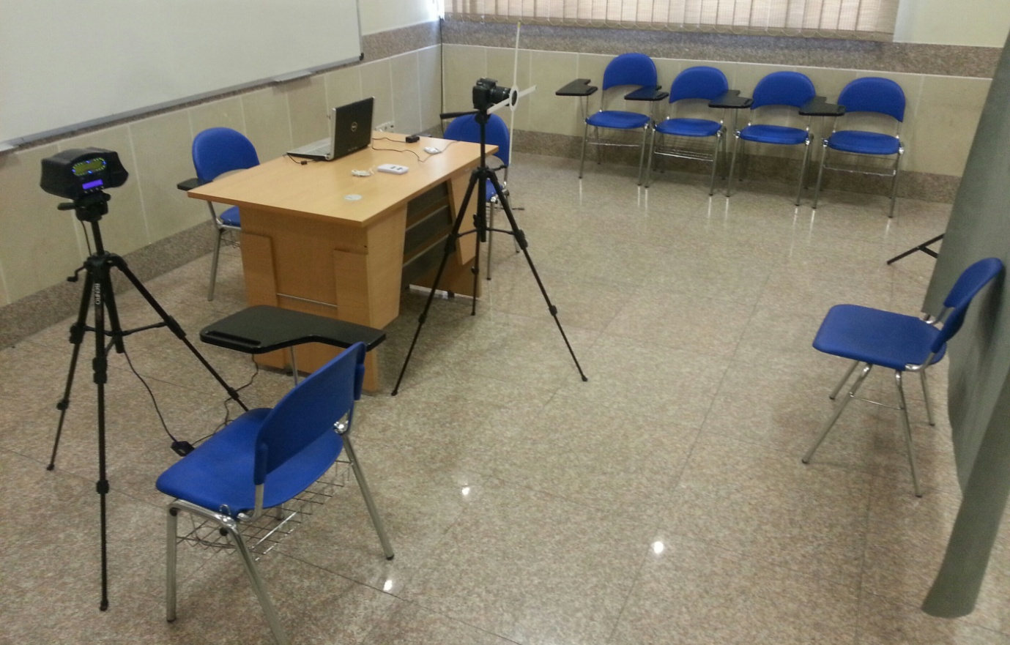

Multi-biometric research laboratory

**People:**

**Supervisor:**

Dr. Morteza AnaLoui , Associate Professor of Computer Engineering, College of Computer Engineering, Iran University of Science and Technology

Email : [analoui@iust.ac.ir](mailto:analoui@iust.ac.ir)

Website : <http://www.iust.ac.ir/find.php?item=14.729.580.en>

**students :**

Name : Seied Hassan Tabatabai

Field of Study: Computer Engineering – Artificial Intelligence

Degree: Master Student

Research Area : Fusion of Biometric Data set

Email : [Hassan_tabatabaei@comp.iust.ac.ir](mailto:Hassan_tabatabaei@comp.iust.ac.ir)

Name : Elham Seddighi

Field of Study: Computer Engineering – Artificial Intelligence

Degree: Master Student

Research Area : measurements and stored protocols of biometric dataset

Email : [e_sedighi@comp.iust.ac.ir](mailto:e_sedighi@comp.iust.ac.ir)

Name : mahdi Kazemi

Field of Study: Computer Engineering – Artificial Intelligence

Degree: Master Student

Research Area : Biometric Systems Authentication

Email : [mahdi_kazemi@cmps2.iust.ac.ir](mailto:mahdi_kazemi@cmps2.iust.ac.ir)

Name : Sara Shahsavarani

Field of Study: Computer Engineering – Artificial Intelligence

Degree: Master Student

Research Area : Biometric Authentication Systems

Email : [sara_shahsavarani@cmps2.iust.ac.ir](mailto:sara_shahsavarani@cmps2.iust.ac.ir)

Name : Donya Afsharjahanshahi

Field of Study: Computer Engineering – Artificial Intelligence

Degree: Master Student

Research Area : Biometric Authentication Systems

Email : [afsharjahanshahi@cmps2.iust.ac.ir](mailto:afsharjahanshahi@cmps2.iust.ac.ir)

Name : Mahta Hassanpour

Field of Study: Computer Engineering – Artificial Intelligence

Degree: Master Student

Research Area : Biometric Authentication Systems

Email : [mahta_hassanpour@cmps2.iust.ac.ir](mailto:mahta_hassanpour@cmps2.iust.ac.ir)